Basic inorganic principles

Electronic structures of atoms
Atoms consist of three fundamental types of particles: protons, electrons and neutrons. Neutrons and protons have approximately the same mass and, in contrast to this, the mass of an electron is negligible. A proton carries a positive charge, a neutron has no charge and an electron is negatively charged. An atom contains equal numbers of protons and electrons and therefore, overall, an atom has no charge. The nucleus of an atom contains protons and neutrons only, and therefore is positively charged. The electrons occupy the region of space around the nucleus. Therefore, most of the mass is concentrated within the nucleus.
Within an element, the atomic number (Z), that is, the number of protons and electrons is always the same, but the number of neutrons and therefore the mass number (A) can vary. These possible versions of an element are called isotopes
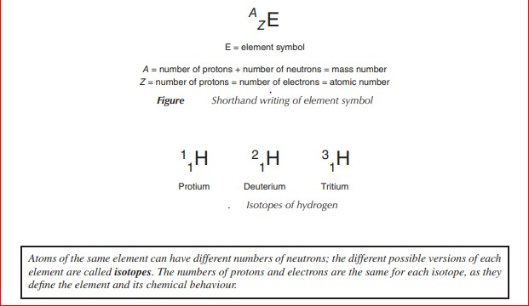

1- Principle quqntum nunber (n):
. It can take values of 1, 2,3, …… it represent the energy level at which the electron rotates.

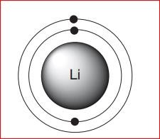

. The quantum number( l)
Represents the shape of the atomic orbital AO. It is called the orbital quantum number as it represents the orbital angular momentum of the electron. It can have values of l =0, 1, 2, …, (n−1), which correspond to the orbital labels s, p, d and f. (shape)
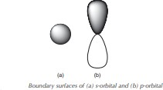

The magnetic quantum number ml
Provides information about the orientation (directionality) of the AO and can take values between +l and −l. This means that there is only one direction for an s- orbital, as l =0, and therefore ml also is equal to 0. For a p-orbital, l=1 and therefore ml is −1, 0 or 1, which means it can occupy three orientations. In this case, they are classified as the px, py and pz orbitals. (orientation)

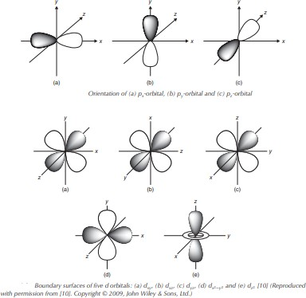

The spin quantum number
Each individual electron can be described by an additional fourth quantum number, the so-called spin quantum number s (value of either +1/2 or −1/2). Each orbital can be filled with one or two electrons. Once an orbital is filled with two electrons, they will occupy opposite spin directions in order to fulfill the Pauli Exclusion Principle

The Pauli Exclusion Principle states that no two electrons in the same atom can have the same values for their four quantum numbers
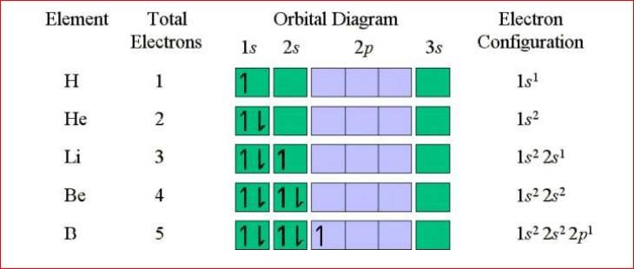

Valence Electrons
The valence electrons are the electrons in the last shell or energy level of an atom.
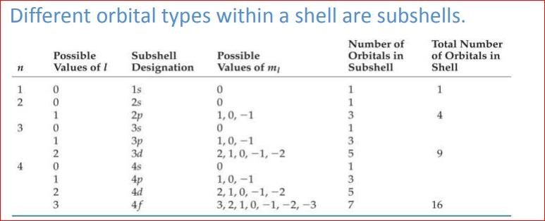

Lewis structures and Lewis Theory

The octet rule:
All elements except hydrogen ( hydrogen have a duet of electrons) have octet of electrons once they from ions and covalent compounds.
The Lewis dot symbols for atoms and ions shows how many electrons are need for an atom to fill the octet. Normally there are octets of electrons on most monatomic ions.
A Lewis symbol is a symbol in which the electrons in the valence shell of an atom or simple ion are represented by dots placed around the letter symbol of the element. Each dot represents one electron.
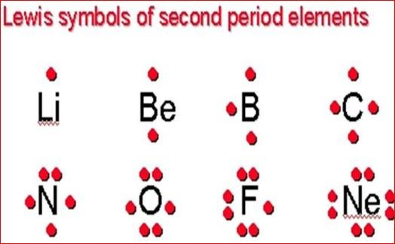

For any compounds, other than Nobel gases, it is necessary to maintain the octet rule. Octet rule is obtained by bond formation.

A covalent bond

Is a chemical bond formed by the sharing of a pair of electrons between two atoms.
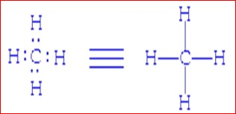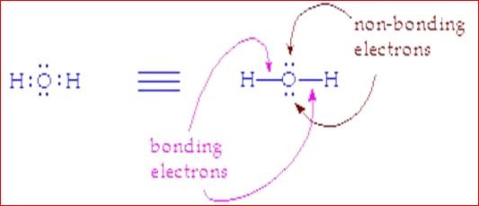
Bond pair: electron pair shared between two atoms.
Lone pair: electron pair found on a single atom.

Ionic bond:
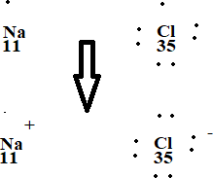
It involves formation of ions, complete the octet rule, and the attraction between different ions
Orbital hybridization

In chemistry, orbital hybridisation (or hybridization) is the concept of mixing atomic orbitals to form new hybrid orbitals (with different energies, shapes, etc., than the

component atomic orbitals) suitable for the pairing of electrons to form chemical bonds in valence bond theory.

Types of hybridisation
SP3:
Hybridisation describes the bonding of atoms from an atom's point of view. For a tetrahedrally coordinated carbon (e.g., methane CH₄), the carbon should have 4 orbitals with the correct symmetry to bond to the 4 hydrogen atoms.
Carbon's ground state configuration is 1s² 2s² 2p² or more easily read:
The carbon atom can use its two singly occupied p-type orbitals to form two covalent bonds with two hydrogen atoms, yielding the singlet methylene CH₂, the simplest carbene. The carbon atom can also bond to four hydrogen atoms by an excitation (or promotion) of an electron from the doubly occupied 2s orbital to the empty 2p orbital, producing four singly occupied orbitals. The energy released by the formation of two additional bonds more than compensates for the excitation energy required, energetically favoring the formation of four C-H bonds.
Quantum mechanically, the lowest energy is obtained if the four bonds are equivalent, which requires that they are formed from equivalent orbitals on the carbon. A set of four equivalent orbitals can be obtained that are linear combinations of the valence-shell (core orbitals are almost never involved in bonding) s and p wave functions,^{[9]} which are the four sp³ hybrids.

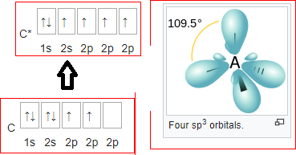

In CH₄, four sp³ hybrid orbitals are overlapped by hydrogen 1s orbitals, yielding four σ (sigma) bonds (that is, four single covalent bonds) of equal length and strength.

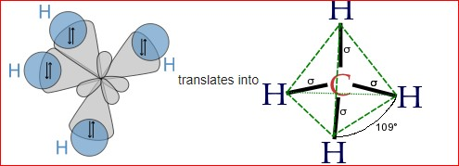

SP2:
Other carbon compounds and other molecules may be explained in a similar way. For example, ethene (C₂H₄) has a double bond between the carbons.
For this molecule, carbon sp² hybridises, because one π (pi) bond is required for the double bond between the carbons and only three σ bonds are formed per carbon atom. In sp² hybridisation the 2s orbital is mixed with only two of the three available 2p orbitals, usually denoted 2p_{x} and 2p_{y}. The third 2p orbital (2p_{z}) remains unhybridised. forming a total of three sp² orbitals with one remaining p orbital. In ethylene (ethene) the two carbon atoms form a σ bond by overlapping one sp² orbital from each carbon atom. The π bond between the carbon atoms perpendicular to the molecular plane is formed by 2p–2p overlap. Each carbon atom forms covalent C–H bonds with two hydrogens by s– sp² overlap, all with 120° bond angles. The hydrogen–carbon bonds are all of equal strength and length, in agreement with experimental data.
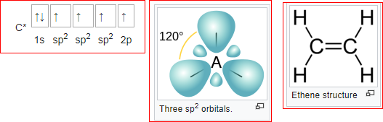

SP:
The chemical bonding in compounds such as alkynes with triple bonds is explained by sp hybridization. In this model, the 2s orbital is mixed with only one of the three p orbitals, resulting in two sp orbitals and two remaining p orbitals. The chemical bonding in acetylene (ethyne) (C₂H₂) consists of sp–sp overlap between the two carbon atoms forming a σ bond and two additional π bonds formed by p–p overlap. Each carbon also bonds to hydrogen in a σ s–sp overlap at 180° angles.

